**Buyer Company--Okana**



**URL:** okana.toppromotions.com/store

**PMS or Hex color scheme:**

**FONT: Brother 1816**

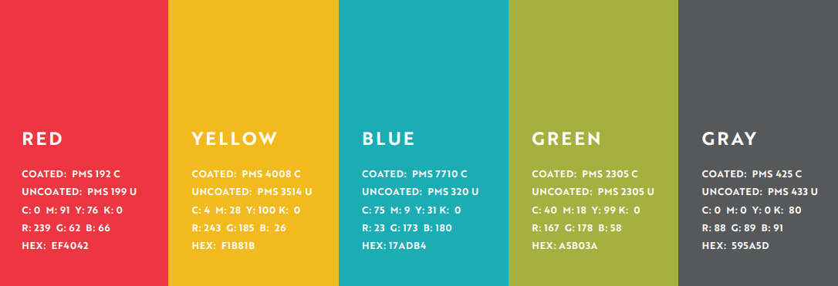

Art Dept mockups of what the home page would look like with varying heights of category images.

**NOTE: footer would be on bottom as usual**

Have put all height sizes in the drop box so you have to see what fits best.

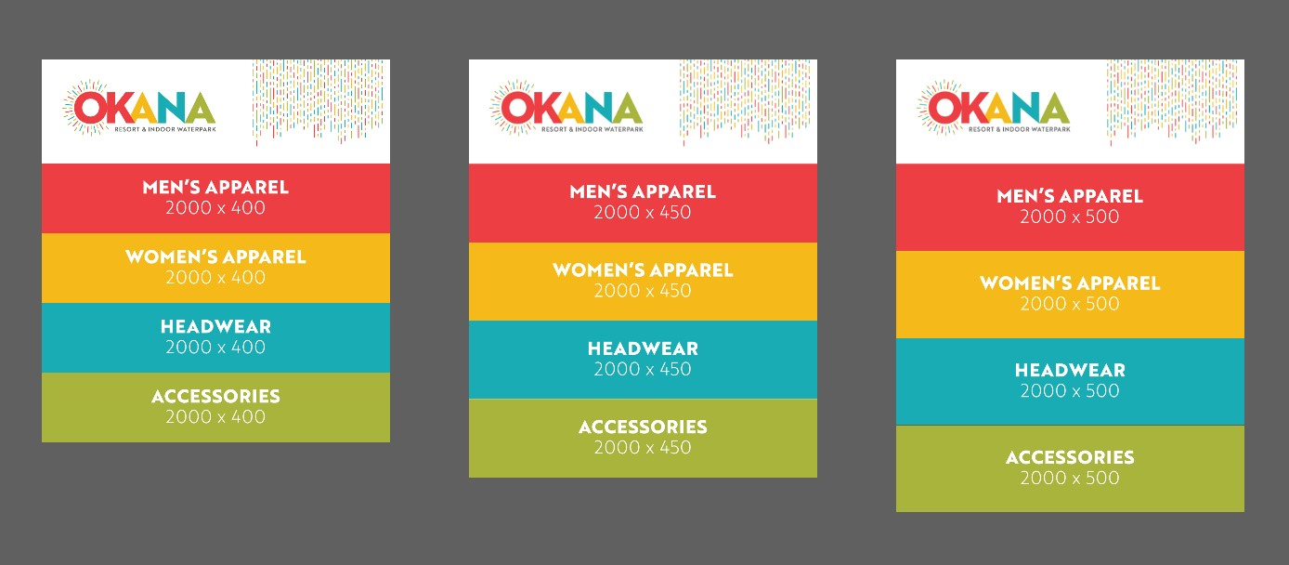

**Vector Files for Logo’s:** in drop box

**Banner**: in drop box

**Footer:** same as all other stores with the Top logo and contact info

**Home Page Text**

*No home page text*

**Info for “Help” Page**

Customer Service

If you have any questions about your order, please contact Top Promotions via e-mail at [webservices@toppromotions.com](mailto:webservices@toppromotions.com) or at 608-826-6990. Office hours are Monday-Thursday 8am-5pm, Friday 8am-1pm CST.

Product Delivery

Items will ship to the address you provide via USPS or UPS standard rates.

For questions regarding the website or an existing order please contact Top Promotions Customer Service at [webservices@toppromotions.com](mailto:webservices@toppromotions.com) or 608-826-6990

Returns/Exchanges

Each item is custom made for your order, so we appreciate your understanding that returns/exchanges are not available except in the case of an item defect.

**Payment**

Credit Card Purchases

You may pay via credit card when you checkout. Your card will be pre-authorized at that time. The actual charge will be made when the order is shipped.

**Other Custom Text Required:**

**View Cart Page: none**

**Login Page: none**

**Billing Page**

Credit Card Purchases

The billing address should match the address on file for the credit card being used to place this order.

**Password Protected?** NO